SEEDLESS VASCULAR PLANTS

This group includes the Club Mosses (Phylum Lycophyta), Horsetails (Phylum Sphenophyta), and Ferns (Phylum Pterophyta). These are very ancient plants that were prevalent during the Carboniferous period of Earth formation.
The SPOROPHYTE IS DOMINANT in the Seedless Vascular Plants, Meaning that they spend slightly more time as a sporophyte than a gametophyte. The sporophyte has adaptations to help it survive the harsh conditions of land, such as a VASCULAR SYSTEM and WIND DISPERSED SPORES (don’t need water). The spores will germinate and produce a small gametophyte generation. The gametophyte generation retains properties that are not adapted for land, such as NO VASCULAR SYSTEM and FLAGELLATED SPERM.

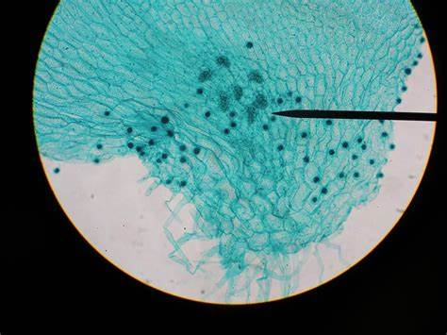
STRUCTURE: ENTIRE
PROTHALIUM
Domain: Eukarya
Kingdom: Plantae
Group: Polypodiophyta
Phylum: Ptreidophyta
Genus: Prothallus

STRUCTURE: ANTHERIDIA
(Located on Prothalium)
Domain: Eukarya
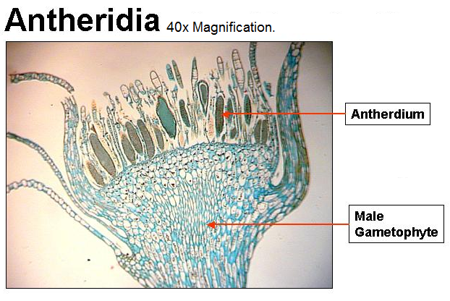
Kingdom: Plantae
Group: Bryophyte
Phylum: Lycophyta
Genus: Bryophyta

STRUCTURE: ARCHEGONIA
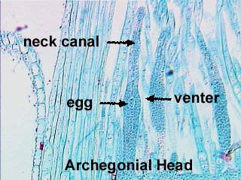
(Located on Prothalium)
Domain: Eukarya
Kingdom: Plantae
Group: Bryophyta
Phylum: Lycophyta
Genus: Bryophyta

STRUCTURE: INDUSIUM/
SPORANGIUM/SORUS
Domain: Eukarya
Kingdom: Plantae
Group: Polypodiopsida
Phylum: Ptreidophyta
Genus: Dryopteris

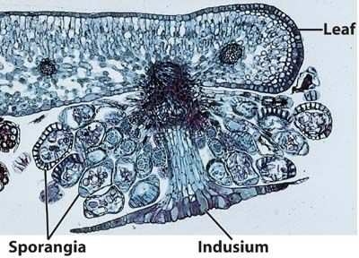

STRUCTURE: PROTHALIUM
WITH SPOROPHYTE
Domain: Eukarya
Kingdom: Plantae
Group: Tracheophyte
Phylum: Pterodophyte
Genus: Prothallus

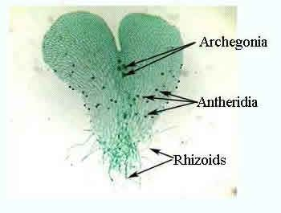

STRUCTURE: FERN
FROND WITH SORI
Domain: Eukarya
Kingdom: Plantae
Group: Polypodiopsida
Phylum: Pteridophyta
Genus: Dryopteris

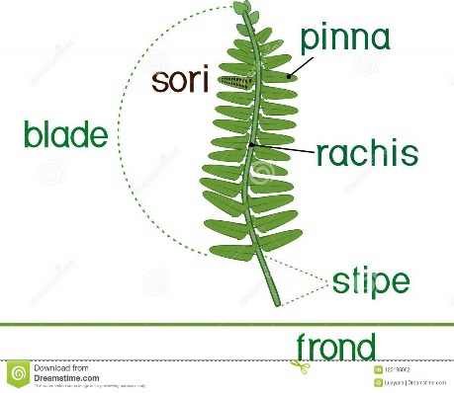

STRUCTURE: WHISKFERN
Domain: Eukarya
Kingdom: Plantae
Group: Pteridophyta
Phylum: Trachediopsida
Genus: Psiloptum

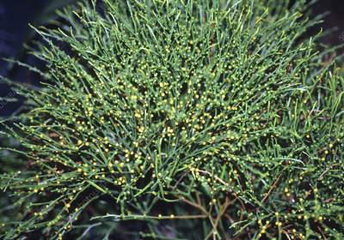

STRUCTURE: LYCOPHYTE
Domain: Eukarya
Kingdom: Plantae
Group: Bryophyta
Phylum: Lycophyta
Genus: Lycopodiophyta

